Alexander Baldree
2/17/26
Module 7.1 Discussion Board
CSD340

#53 Unpredictability Keeps People Searching

Embellishment
One thing I’ve noticed beyond the reading is how unpredictability is heavily used in modern apps to keep people engaged longer than they planned. Social media platforms, games, and even email apps use variable rewards; meaning you don’t know when something interesting will appear. This taps into the same psychology as slot machines.
For example, when I refresh a feed, sometimes I see something exciting, sometimes not. That unpredictability keeps me checking again. Designers use this on purpose to increase engagement time.
A good design takeaway is that unpredictability should be used carefully. It can boost engagement, but too much can feel manipulative or stressful. I think ethical design should balance curiosity with user well-being.

Visual Example

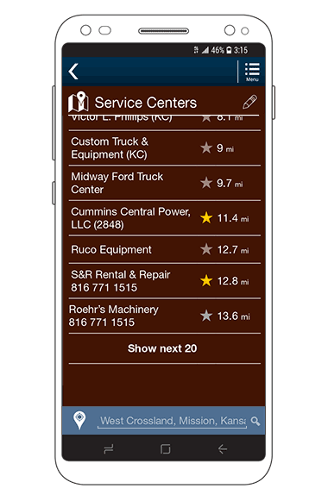

#57 People Are Inherently Lazy

Embellishment
I don’t see “lazy” as a bad trait; it’s more about efficiency. People naturally look for the path that takes the least effort. If a website is confusing or takes too many steps, most users will leave instead of figuring it out.
From my own experience, if a site makes me create an account just to browse, I usually quit. But if it lets me explore first, I’m more willing to sign up later.
Good UX design respects this by reducing friction. Autofill, remembered logins, and simple navigation all help users feel like the site is easy to use. When something feels easy, people stick around.

Visual Example
A simple checkout vs. a complicated checkout shows this idea well.

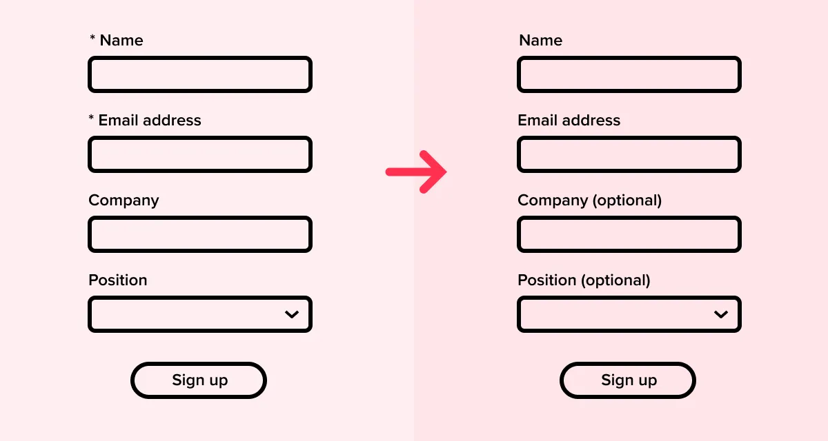
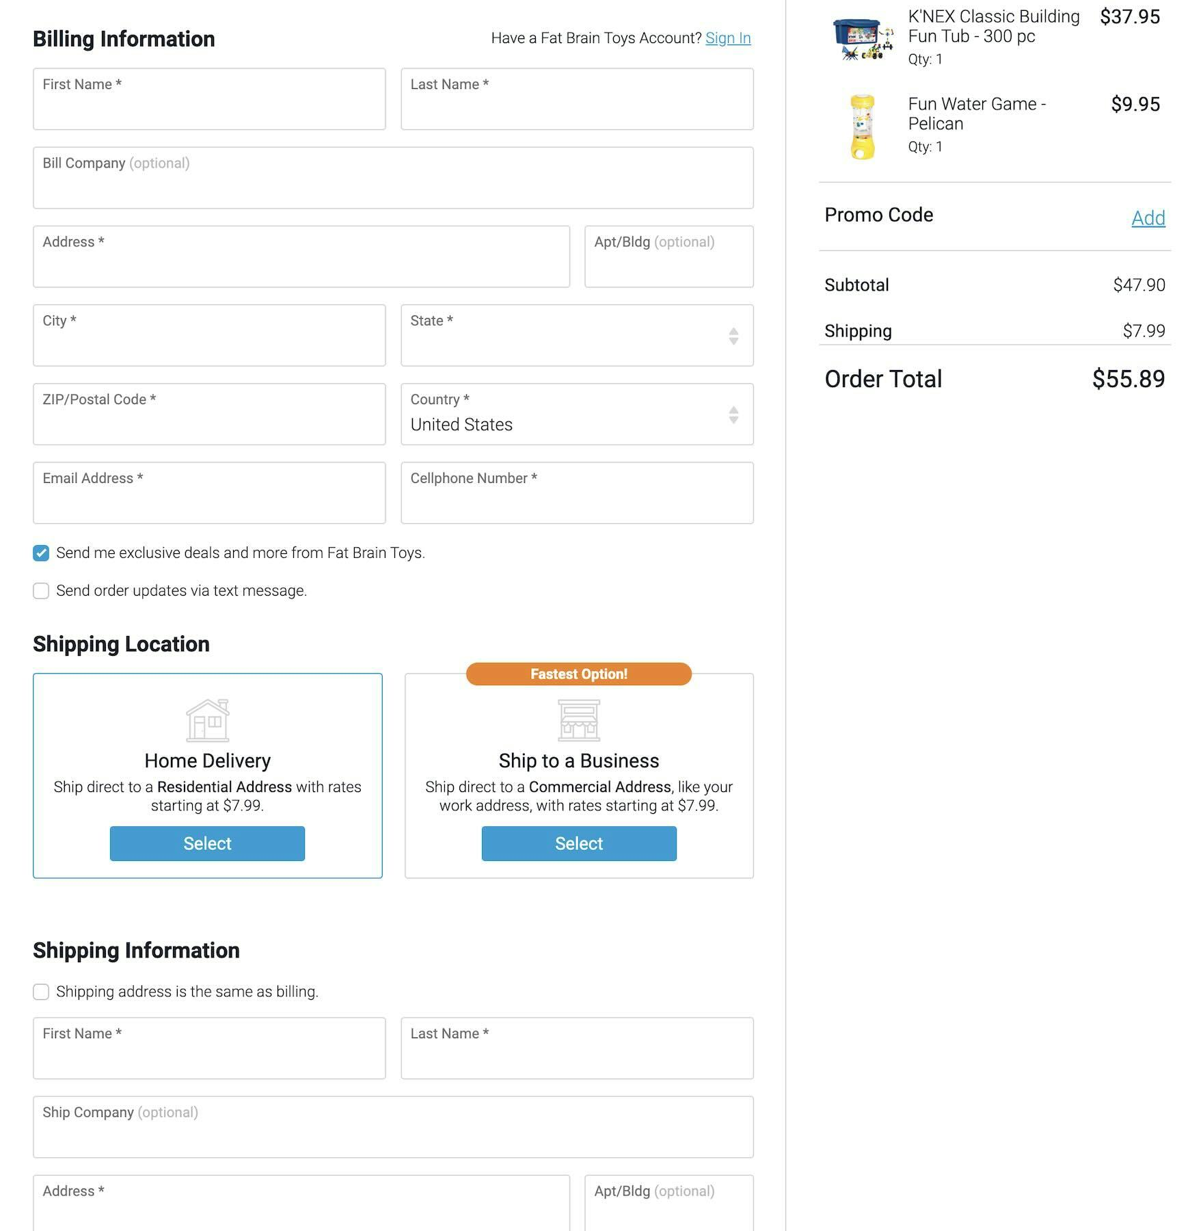

Most users will choose the quick, simple option every time. The easier the process, the more likely they are to complete it.

References:
100 Things Every Designer Needs To Know About People Susan M. Weinschenk, Ph.D.
Topic 53: Unpredictability Keeps People Searching Pg.125-126
Topic 57: People are Inherently Lazy Pg. 132-134

